NAAN MUDHALVAN ARTS INTERNSHIP PROGRAM 2026
Frontend Web Development using React
Project Submission Template

STUDENT NAME: FATHIMA FIRDOSE.A
YEAR: III
COLLEGE CODE: 413
COLLEGE NAME: DEEN COLLEGE OF ARTS AND SCIENCE
DEPARTMENT: COMPUTER SCIENCE
SEMESTER: V
ROLL NO: 24134131802522006
NMID: asanm41341324214006
DATE: 26/06/2026
TITLE: Daily Expense Analytics Dashboard
GITHUB LINK : https://github.com/dccs24fathima-firdose/REACT-APP-DEVELOPMENT-.git

- ABSTRACT
The Daily Expense Analytics Dashboard is a frontend web application designed to help working professionals manage and analyze their daily income and expenses. The application allows users to add income and expense records, categorize transactions, calculate total balance, and view spending patterns through basic analytics. This project provides an easy and efficient way to track financial activities and understand spending habits using a simple dashboard interface
- PROBLEM STATEMENT
Many working professionals find it difficult to monitor their daily spending and maintain proper financial records. Tracking expenses manually can be time-consuming and may lead to poor money management. This project aims to solve this problem by providing a digital dashboard where users can record transactions, categorize expenses, and analyze their spending behavior.

3. OBJECTIVES
• To create a user-friendly expense tracking dashboard.
• To allow users to add income and expense details.
• To categorize expenses for better understanding.
• To calculate total available balance automatically.
• To provide basic analytics based on spending categories.
• To improve financial awareness and money management.

4. PROJECT SCOPE
The project includes features such as adding income and expense transactions, category-wise expense tracking, balance calculation, and displaying spending summaries. The application focuses on personal finance monitoring.
Future enhancements may include: • User login system
• Database integration
• Monthly reports
• Graph-based analytics
• AI-based spending suggestions

5. TECHNOLOGIES USED
Frontend Technologies:
- HTML5
- CSS3
- JavaScript
Development Tools:
- VS Code / Acode Editor
- Web Browser
Libraries (Optional):
- Chart.js for analytics visualization

6. APPLICATION FLOW
- User opens the Expense Dashboard.
- User enters transaction details such as amount, type, and category.
- System stores the transaction data.
- Dashboard updates total income, total expenses, and balance.
- Expense categories are analyzed.
- User can view spending summaries and understand financial patterns.

7. KEY REACT CONCEPTS USED
HTML: Used to create the structure of the dashboard including forms, cards, and sections.
CSS: Used for designing an attractive interface with layouts, colors, and responsive design.
JavaScript: Used to add functionality such as transaction handling, calculations, and dynamic updates.
DOM Manipulation: Used to update dashboard content without refreshing the page.
Local Storage: Used to save transaction details in the browser.
8.EXPECTED OUTPUT
The final output is a responsive Daily Expense Analytics Dashboard where users can:
• Add income and expenses
• View total balance
• Track category-wise spending
• Analyze expense summaries
• Manage daily financial records easily
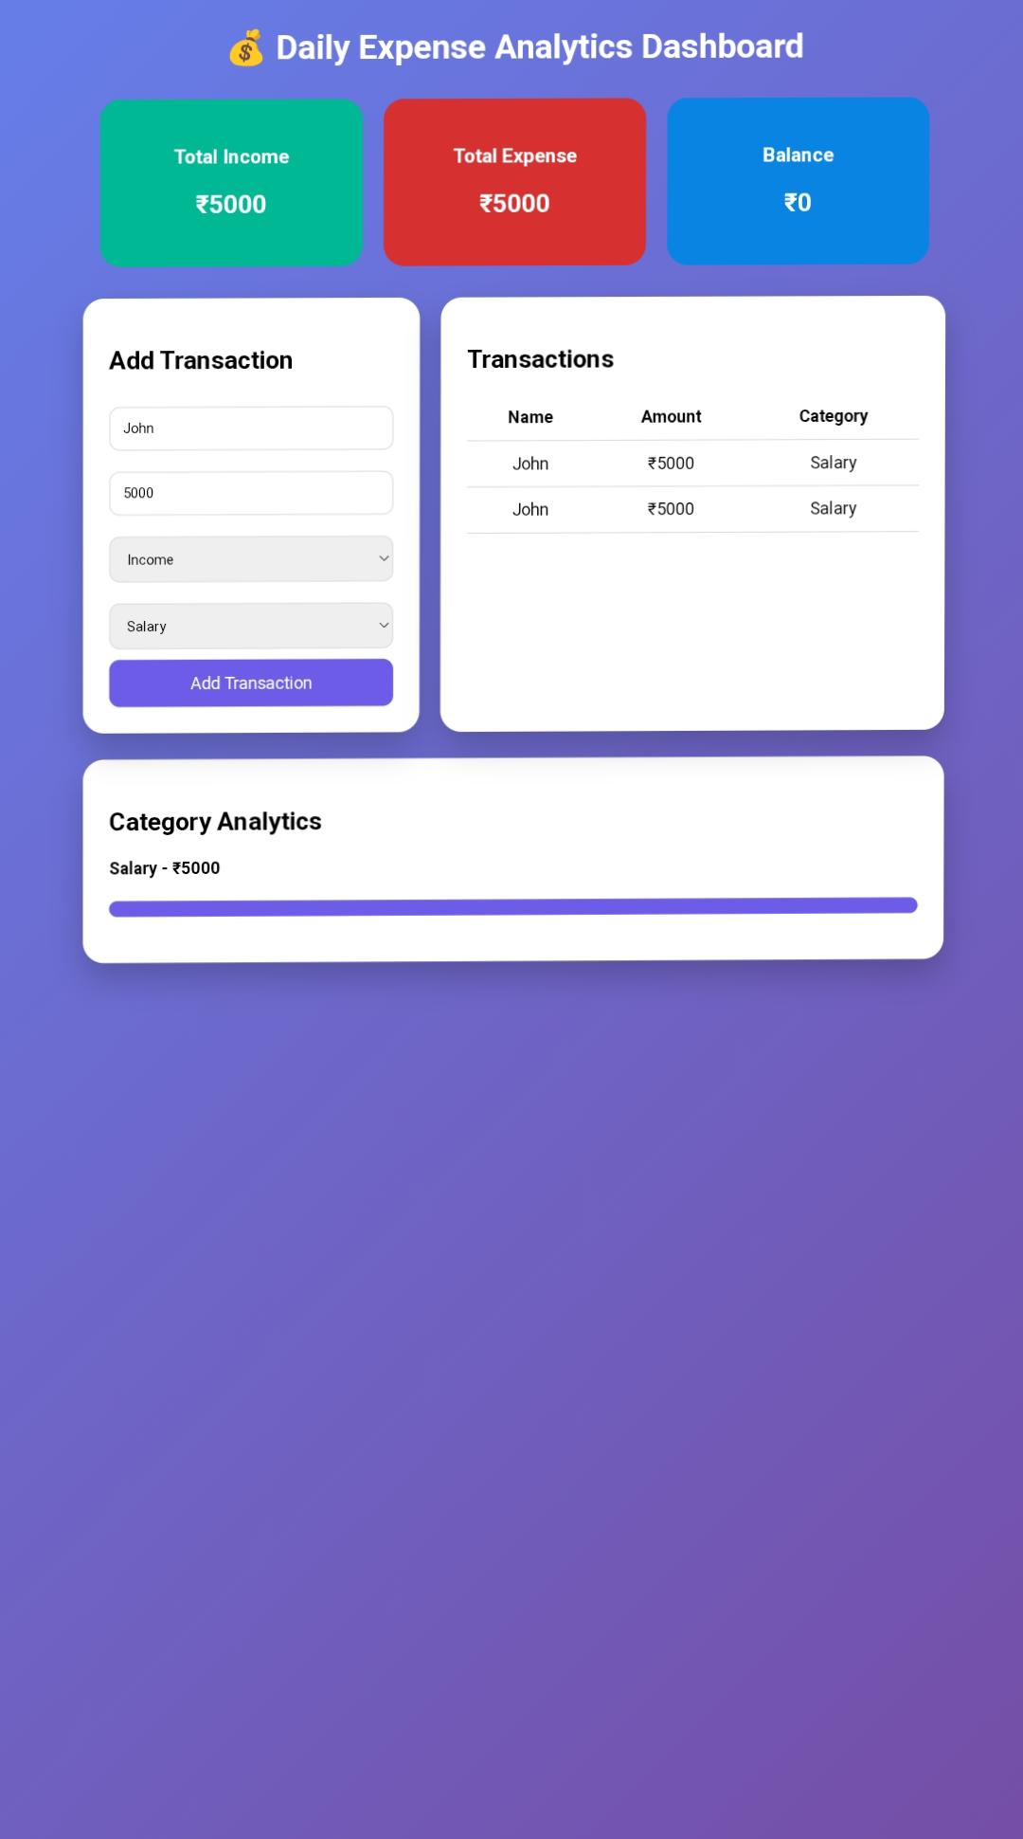

9. CHALLENGES FACED
• Designing a clean dashboard interface.
• Managing transaction data dynamically.
• Implementing accurate balance calculations.
• Creating category-based expense analysis.
These challenges were solved by improving JavaScript logic and testing different user inputs.

10. LEARNING OUTCOMES
Through this project, I learned:
• Frontend web development concepts
• HTML structure creation
• CSS designing techniques
• JavaScript programming and DOM manipulation
• Building interactive web applications
• Managing user data efficiently

11. CONCLUSION
The Daily Expense Analytics Dashboard successfully provides a simple solution for tracking personal finances. The project helps users monitor income, expenses, and spending patterns through an interactive interface. It improves financial management skills and demonstrates the practical use of frontend web development technologies

